TR-JB07-IN 7-inch Junction Box
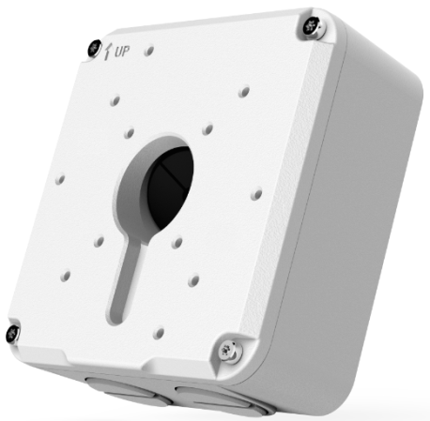

Specifications
Model | TR-JB07-IN
Application | Outdoor or indoor cable junction box for IPC2XX and IPC32X series
Dimensions | 126mmx125mmx55mm (5” x4.9” x2.2”)
Weight | 0.72kg(1.6lb)
Material | Aluminium alloy

Dimensions
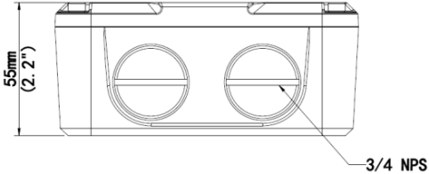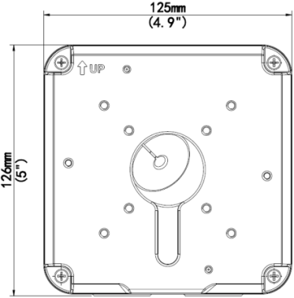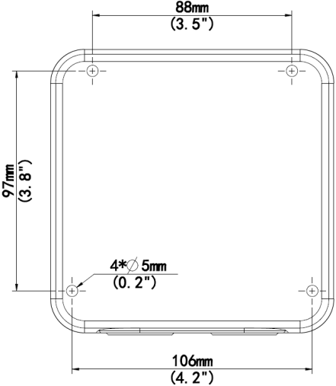

Zhejiang Uniview Technologies Co.,Ltd.
South Tower, Building 10, Wanlun Science Park, 88 Jiangling Road, Hangzhou, P.R.China 310051
Email：overseasbusiness@uniview.com;globalsupport@uniview.com
http://www.uniview.com
©2015 Zhejiang Uniview Technologies Co.,Ltd. All rights reserved.
*Product specifications and availability are subject to change without notice.

